Ex. No.: 9

Query with Joins – EquiJoin, InnerJoin, OuterJoin 1)
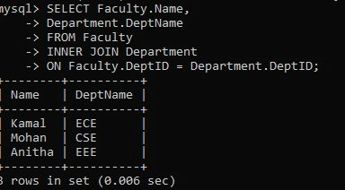
2)
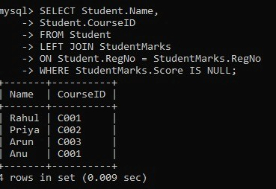
3)
